Portrait Stories
Steve Forster
All required materials are listed in regular font. All suggested materials are marked with an * and italicized.

Materials
Paints:

- Titanium White (Gamblin)
Flake White #2 * $$$ Williamsburg Oil Colors
- Cad Yellow Lt.
- Yellow Ochre
- Cad Orange
- Cad Red Medium
- Alizarin Crimson
- Burnt Sienna (Winsor Newton)
- Ivory Black
- Dioxizine Purple
- Ultramarine Blue
- Pthalo Blue
- Pthalo Turquoise
- Permanent Green Lt.

Brushes:
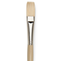
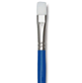
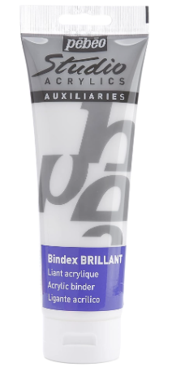
- Bristle Flat brushes 4, 6, 8, 12. Robert Simmons Signet and Princeton Ashley series are great.
- Blick Wonder White Flats 8, 12, 20
- Several Small synthetic round brushes for drawing
- One or two larger sable rounds or fans for softening.

Supports, Mediums, Palette, Etc. :
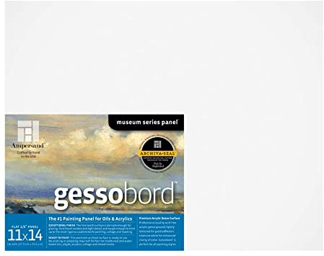
- 2H Pencil (Dull) 2B Pencil (Sharp) Mechanical Pencil Preferred
- Ruler
- 1 Larger panel or Canvas either 18 x 24 or 24 x 30
- White Paper palette 12 x 16
- Liquin Original
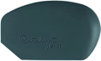
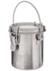
- Linseed Oil and Gamsol/OMS
- *Catalyst wedge rubber tools, mini 04 from Blick
- Brush Washer

